**Robustness Diagrams:**

View Reservations:

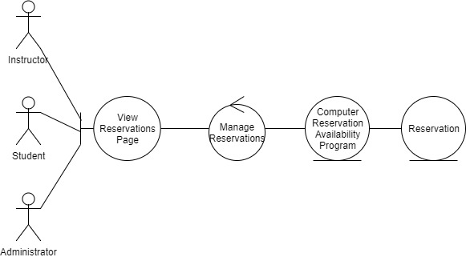

Reserve Room:

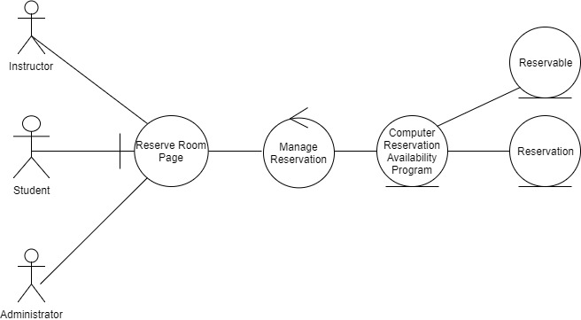

Reserve Computer:

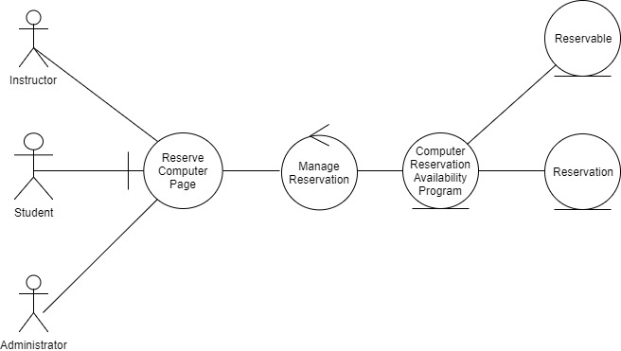

Edit Reservation:

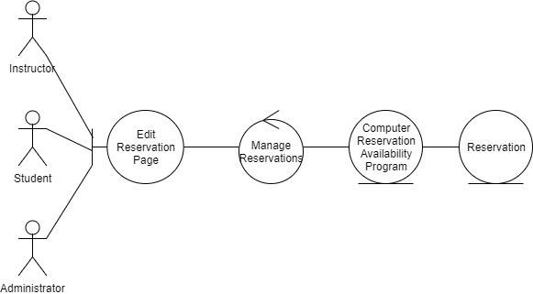

Checkout Reservable:

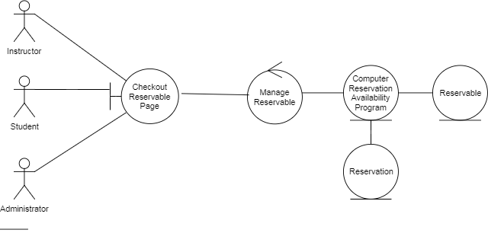

Add Reservable:

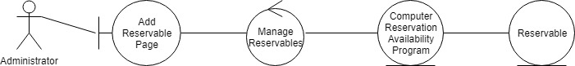

View Reservables:

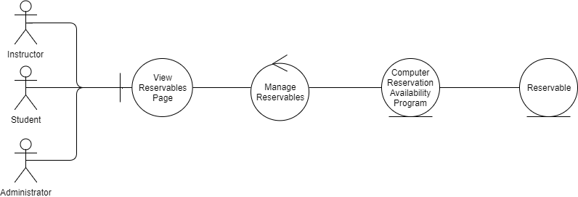

Cancel Reservation:

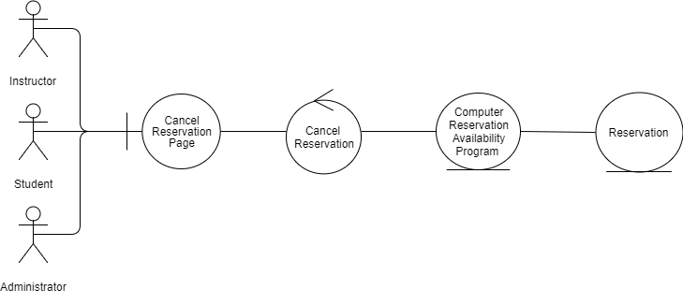

Remove Reservable:

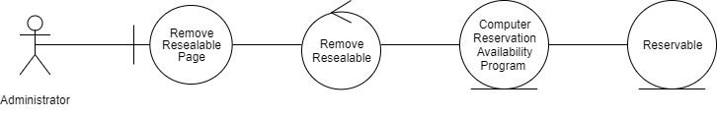

**Collaboration/Sequence Diagrams:**

Add Reservable:

1. Provide reservable information
2. Pass reservable information
3. Pass reservable information
4. Create reservable
5. Return reservable
6. Reservable added
7. Reservable added
8. Reservable added

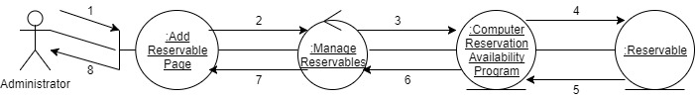

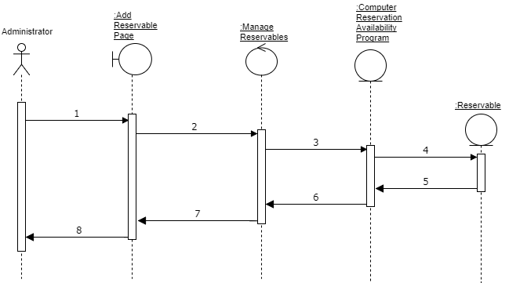

Reserve Computer:

1. Request to reserve a computer
2. Pass reservation info
3. Pass reservation info
4. Create Reservable
5. Return Reservable
6. Create Reservation
7. Return Reservation
8. Reservation Added
9. Reservation Added
10. Reservation Added 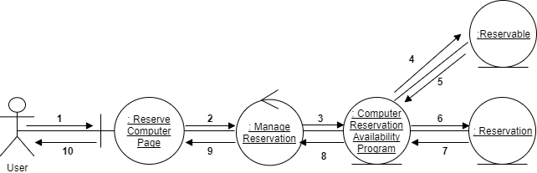

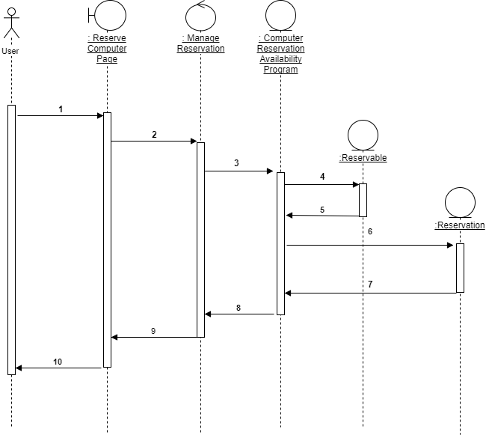

Remove Reservable:

1. Select the reservable to remove
2. Pass reservable information
3. Pass reservable information
4. Delete reservable
5. Reservable deleted
6. Successfully removed
7. Successfully removed
8. Successfully removed

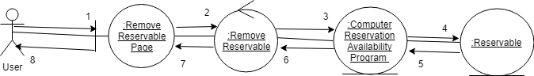

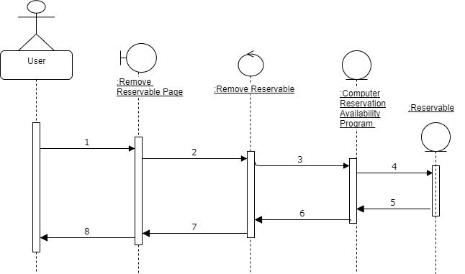

**Teamwork Dynamics:**

We identified several problems we had during the first few weeks of this project.

1. We were unorganized in determining meet up times.
2. Not everyone would show up to meetings
3. We didn’t have a designated place to hold our project files.
4. Not everyone had access to all the project files at one time.
5. Extra work was needed by 1 or 2 people because they were the only ones who had full access to the files for uploading assignments.

These problems were detrimental to the project, so we have taken steps to eliminate these issues.

1. We set weekly meeting times that don’t change
2. We Created a GitHub repository for version control and storage

The weekly meetings were set at times everyone was available. This eliminated conflicting schedules allowing everyone to show up to each meeting. It also helped us have a more consistent work flow from week to week.

The GitHub repository allowed everyone to have access to the files at any time. This eliminated the issue our group had dividing up the work.